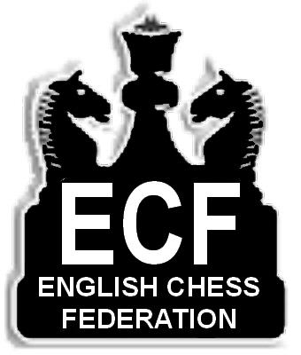
Entry Form - Block Capitals please
Name............................................... Male/Female.......
Address........................................................................
...........................................Post Code......................
Phone...............................Club..................................

ECF Membership Number…………………………
ECF R/play grades http://grading.bcfservices.org.uk/
Grade ………………....Source……………………….

NB: Players without a grade MUST give details of
their playing strength on a separate sheet.
EVENT DESCRIPTION TICK
1 Open (Sat/Sun £33) □ £......
2 Major (Sat/Sun £30) □ £......
3 Intermediate (Sat/Sun £28) □ £......
4 Minor (Sat/Sun £26) □ £......
5 One day rapidplay (Sun only £16) □ £.....
6 England u/11 trial (Sat only £14) □ £.....
7 Junior One Day (Sat only £14) □ £......
8 Brit. Jun. Rapidplay (Sun only £14) □ £.....
Late entry surcharge (£6/£12) † □ £.....
(For entries on or after November 15th, 2010)
Optional Donation □ £......

½ pt bye if required 1st round please tick □
Byes for other rounds:advise controller on the day
Less ECF/NMS discount if it applies (£3) □ £......
TOTAL ENCLOSED £……

Would you like an entry form posted for the 2011 event?

Yes - □ No - □ Please fill in/tick as appropriate
Juniors - Date of birth: / / .
Disabled - □ Senior (before 1/09/50) - □
Valid ECF and NMS members can deduct £3 from
their entry …..... ECF - □ NMS Member - □

Membership Number:...........................................

Postal orders and cheques should be made
payable to British Rapidplay & addressed to:
S. Burton, The Treasurer, 4 Osbourne Court,
Back Lane, Bramley, LS13 4BN.

†All entries postmarked on or after Monday 15th
November are subject to a £6 surcharge. Entries on
the day are subject to a £12 surcharge.

LATE ENTRIES CLOSE AT 10.30 am.

Timetable of events

Saturday November 20th

OPENING CEREMONY 11.45 am
Round 1. 12.00 pm - 1.00 pm
Round 2. 1.30 pm - 2.30 pm
Round 3. 3.00 pm - 4.00 pm
Round 4. 4.30 pm - 5.30 pm
Round 5. 6.00 pm - 7.00 pm
Round 6. 7.30 pm - 8.30 pm
Sunday November 21st
Round 7. 9.30 am -10.30 am
Round 8. 11.00 am -12.00 pm
Round 9. 12.45 pm - 1.45 pm
Round 10. 2.15 pm - 3.15 pm
Round 11. 3.45 pm - 4.45 pm

PRIZE GIVING CEREMONY
5.20 pm Approx.

RATE OF PLAY/DEFAULT RULES

Each player has thirty minutes to complete
the game.E.C.F. Rapid play rules apply.

E.C.F.default rules apply. A player arriving
more than ten minutes late will then be
defaulted.Re-pairings will take place ten
minutes after start of play.

OTHER INFORMATION

Visit www.british-rapidplay.org.uk
or contact:

Entries- Steve Burton

Tel: (0113) 2568157

Grading queries …please checkout
http://grading.bcfservices.org.uk/

Note: the venue has restrictions on the
use of mains power for laptops.

BRITISH

RAPIDPLAY

CHESS

CHAMPIONSHIPS
2010

At North Bridge

Leisure Centre,

Halifax, HX3 6TE

Tel: 01422 341527

Sat 20th / Sun 21st
November 2010

An English Chess Federation

Supported Grand Prix Event

Live coverage on the internet site
www.british-rapidplay.org.uk

SENIOR EVENTS

(1) THE OPEN CHAMPIONSHIP
Open to all.

Entry fee - £33
Prizes - £600, £300, £150 , £85, £50 plus grading prizes

FREE ENTRY to GMs, IMs, WGMs & WIMs
for entries received by 16th November.

(2) THE MAJOR CHAMPIONSHIP

Open to players graded below 171
Entry fee - £30
Prizes - £400, £200, £120, £80, £50 plus grading

(3) THE INTERMEDIATE

CHAMPIONSHIP

Open to players graded below 146
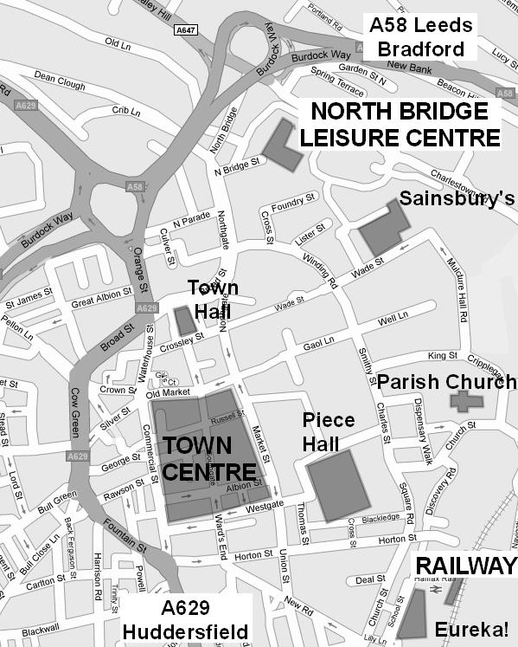
Entry fee - £28

Prizes - £350, £180, £110, £70, £50 plus grading prizes
(4) THE MINOR CHAMPIONSHIP

Open to players graded below 121
Entry fee - £26
Prizes - £300, £150, £100, £70, £50 plus grading prizes

(5) SUNDAY ONLY RAPIDPLAY
Open to all players. Five rounds only.
Entry fee - £16

PRIZES SUBJECT TO ENTRY

JUNIOR EVENTS

SATURDAY 20th
(6) AN ENGLAND UNDER 11 TRIAL QUALIFIER

(7) JUNIOR ONE DAY RAPIDPLAY***
SUNDAY 21st
(8) JUNIOR BRITISH RAPIDPLAY
Includes the U16/U14/U12/U10 championships

***Age Limit: Under 16 on 31st Aug 2010
Entry fee - £14 per junior event.

Selected cash /books/certificates/and medals will be given.

Thanks to The Skipton Building Society for their support.
The timetable for junior events may be varied
at the discretion of the controllers.

SMOKING IS NOT ALLOWED IN THE VENUE

AND MOBILE PHONES MUST BE SWITCHED
OFF DURING PLAY.

ACCOMMODATION (B & B)

Wool Merchant 01422 368783 - quote “chess”
Website www.woolmerchanthotel.co.uk Has Italian bistro.
Email enquiries@woolmerchant.co.uk
Double or twin £55 B&B. Single £45 B&B.
This hotel has been used in 2009

Quays (01422) 347700
Duke of York (01422) 202056
Railway (01422) 351209
Golden Lion (01422) 353621
Tower House. (01422) 362481
Victoria (01422) 351209
Plummet Line (01422) 353620

All accommodation is the entrant’s responsibility

Please note that Halifax centre has a one way
system right in the middle.
There is car parking by the leisure centre.

For further general information: Halifax Tourist
Information in the Piece Hall HX1 1RE
Tel: (01422) 368725 halifax@ytbpic.co.uk.

MESSAGE FROM THE COMMITTEE

Welcome to the 2010 British Rapidplay Chess

Championships .The organizing committee strives to
improve the event every year,and your suggestions are
always welcome via our new website .
SOME OF LAST YEAR’S WINNERS
OPEN
Gm MARK HEBDEN and Gm DAVID HOWELL
(Joint Winners)
MAJOR
KEVIN YEOMANS and RHYS CUMMINGS
(Joint Winners)
INTERMEDIATE
ANDREW HARDS
MINOR
BRIAN YARKER and ROD BURROUGHS
(Joint Winners)
ENGLAND U/11 DANIEL ABBAS
JUNIOR U/16 EDMUND CHUI
JUNIOR U/14 MILES EDWARD-WRIGHT
JUNIOR U/12 HARRY LI
JUNIOR U/10 ZHEMING ZHANG

BOOKSTALL
Courtesy of Chess Direct Ltd., PO Box 18, Mexborough,
S64 9AR. Tel: (01709) 890565 www.chessdirect.co.uk

REFRESHMENTS
Food, drink, and bar will be available at certain times.

PARKING

Saturday--a small fee applies. Sunday--free parking

SPECIAL NOTES

The organizers reserve the right to increase or decrease the
prizes dependent on the number of entries. Any adjustment
will be announced prior to Round Six.

CONTROLLERS

Congress Director -David Welch .Arbiters –P.Purland

G.Jones, R.Hart, I.Lewyk, & N.Belifante.If you can
help with setting up please contact br.kitson@sky.com.

The controllers and administrators have the right to decline
entries without liability. Their decisions are final in all chess
match and grading disputes.

GRADINGS
ECF Rapidplay grades A to D take precedence.
However, International, National ,Local Gradings and
recent British Rapidplay results may also be considered
at our discretion. Players without a grade MUST give a
detailed estimate of their strength.

The event is E.C.F. game fee registered and all players’
games will be graded.

